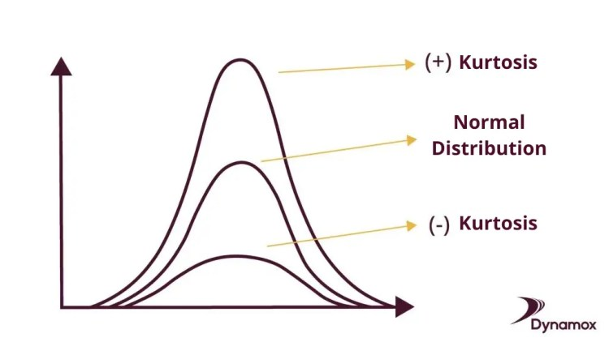

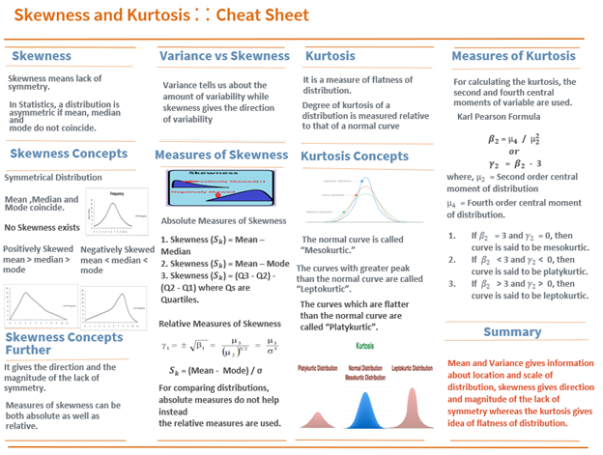

If k= 3 means good to go.

use case for skewness:
Skewness Use Case: Analyzing Income Distribution
- Data Collection: Gather monthly income data from diverse individuals.
- Data Analysis: Calculate skewness to understand income distribution shape.
- Interpretation: Positive skewness indicates income inequality.
- Insights: Inform policymaking, economic analysis, and modeling considerations.
- Modeling: Skewed data may require transformations for accurate modeling.

Kurtosis Use Case: Analyzing Investment Returns
- Data Collection: Gather historical return data for portfolios.
- Data Analysis: Calculate kurtosis to assess risk characteristics.
- Interpretation: Positive kurtosis indicates heavier tails, while negative kurtosis indicates lighter tails.
- Risk Assessment: Higher kurtosis implies higher risk of extreme returns.
- Investment Strategy: Use kurtosis to inform portfolio construction and risk management strategies.
- Modeling Considerations: Consider kurtosis in financial modeling for assessing portfolio risk and designing investment strategies.

Kurtosis in Machine Learning
- Feature Engineering:
  - Identify and transform features with non-normal distributions using kurtosis.
- Transformation:
  - Adjust feature distributions to improve model performance.
- Improved Accuracy:
  - By handling kurtosis, enhance model accuracy and generalization.
- Iterative Process:
  - Experiment and fine-tune feature engineering for optimal results.

